Certification Council for Professional Dog Trainers®
CEU Event Attendance Portal

In an effort to ease the responsibilities of event hosts in collecting certificant information at events, and to ease the responsibilities of certificants when they submit recertification paperwork, the CCPDT has implemented an online CEU Event Attendance Portal. Hosts input attendance information into this portal at the conclusion of the event, and certificants can look online to view their attendance records at any time. This changes the process required for hosts, so instructions on how to utilize the system are given below.

At the Event
During your approved Continuing Education Event, you will need to collect the certificant numbers of all attendees. This can be done in any way you see fit – an online course that uses an automated registration system might keep a list of the certificant numbers of all attendees, while a one-time in-person event might pass around a sign-in sheet. In the interest of security and record-keeping, a paper sign-in sheet should include certificant number, full name, and signature. A sample sign-in form is provided at the end of this document.

After the Event
Note for ongoing events: Event attendees can login at any time and view their CEU attendance history on the CCPDT website. To ensure their information is up-to-date, and so that they can recertify during the event period, it is vitally important that you input attendance multiple times over the one year approval period. Depending on the number of attendees, we suggest monthly or quarterly input.
Note for re-approved events: CCPDT offers hosts the ability to reapply for an already approved event, such as renewing an ongoing event or a repeated in-person event. Each reapplication is a separate approval, and will have a unique validation code and link in the approval e-mail. You must use the most up-to-date approval e-mail for attendance.
- In the approval e-mail, locate and click the attendance link for your event.
- You will be brought to the CCPDT CEU Event Attendance Portal. On this page, you will see your validation code on the first line of the page. Make sure it is correct.
- In the text box, type the e-mail address you used when you applied for the event. If you do not remember what e-mail address you used, please reference the copy of the application sent to you when you applied or the address we sent the approval e-mail to. Click “Submit.”
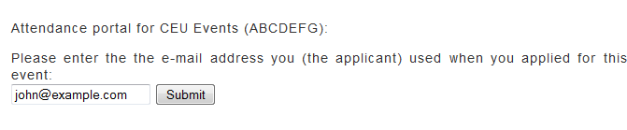
- On Page 2, you will see the title of your event in bold. Make sure that you are inputting information for the correct event.
- In the large box, enter the certificant numbers (and only certificant numbers) for your attendees. These should be 7-digit codes, each on a line by themselves. Avoid any blank lines in the box, including at the end. When you are done, click “Submit.”
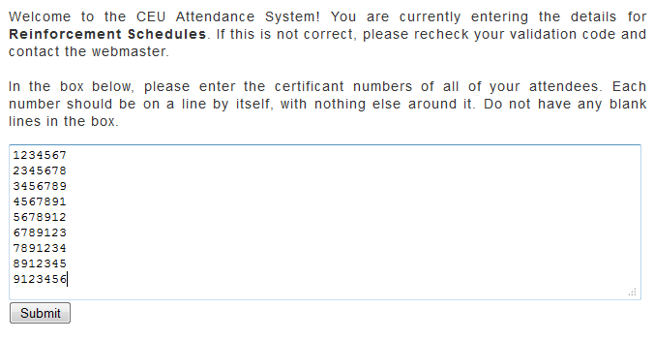
- We will check your input to make sure each line is a valid certificant. If there were any errors, they will be identified and you will need to go back and correct them. Once all certificant numbers are valid, you will see a list of them for confirmation. Please verify this list against your roster to ensure there are no errors. When you are sure of the accuracy, press “Confirm.”
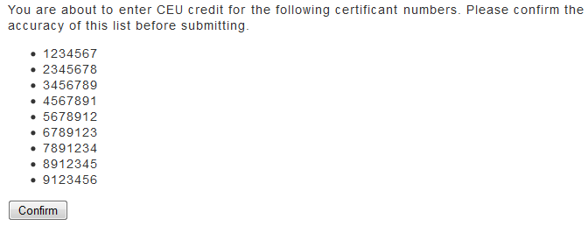
- That’s it! Your attendance records will now be in our system, and certificants will see your event in their CEU History. The CEUs granted for your event will automatically be assigned to the certificants based on which credentials they have, and the “CEUs Remaining” section of their profile will be updated automatically.
Should you have any questions about this process, please feel free to contact the CCPDT Administrator at administrator@ccpdt.org.

Certification Council for Professional Dog Trainers®
Attendance Form
Certificant Number | Full Name | Signature

