

Application of the Humane Hierarchy Position Statement

Purpose

The Humane Hierarchy serves to guide certificants of the Certification Council for Professional Dog Trainers (CCPDT) in their decision-making process during dog training and behavior modification. Additionally, it will assist the public in understanding the standard of care to be applied by dog training and behavior professionals when determining the order of implementation for applying training practices and methodologies.

Policy

Position of the CCPDT

The standard of care for CCPDT certificants is that the Humane Hierarchy will be used as a guide in their decision making process when implementing training and behavior protocols. This standard of care should be followed when the certificant is working directly with a dog, creating a training plan for the client to follow, or assisting a colleague.

Hierarchy of Procedures for Humane and Effective Practices

Please utilize the following steps to modify or manage a behavior:
1. Health, nutritional, and physical factors: The certificant ensures that any indicators for possible medical, nutritional, or health factors are addressed by a licensed veterinarian. The certificant also ensures that factors in the physical environment that have a potential to impact the dog’s health, nutrition and physical condition are addressed.
2. Antecedents: The certificant implements environmental management strategies to prevent the behavior from occurring.
3. Positive Reinforcement, Classical Conditioning (not listed in order of preference):
a. Positive Reinforcement: The certificant ensures that reinforcement is delivered for the desirable alternative behavior, and that such reinforcement is of higher value to the dog than the reinforcement the dog has received in the past for the unwanted behavior.
b. Classical Conditioning: The certificant changes the dog’s association with an aversive stimulus while presenting the aversive stimulus at a sub-threshold intensity.
4. Live With or Manage the Behavior, Negative Punishment, Negative Reinforcement, Extinction, Consult Another Professional (not listed in order of preference):

a. Live With or Manage The Behavior: Certificant elects to cease modification techniques and implement a management plan.
b. Consult Another Professional: At times, it may be beneficial for the certificant to consult another professional such as a dog trainer, veterinarian, or behaviorist for additional advice. Consulting with other professionals can be beneficial, particularly when a problem behavior does not resolve with the previously mentioned interventions.
c. Negative Punishment: The certificant withdraws a positive reinforcer when the undesirable behavior occurs to reduce the probability that the behavior will occur in the future.
d. Extinction: The certificant withholds reinforcement of a previously reinforced behavior with the goal of extinguishing the behavior.
e. Negative Reinforcement: The certificant withdraws an aversive stimulus when the desired behavior occurs in order to increase the probability that the behavior will occur in the future.
5. Positive Punishment: The certificant delivers an aversive consequence in response to the undesirable behavior in order to reduce the probability that the behavior will occur in the future.

The Humane Hierarchy:
This graphic depicts the Humane Hierarchy as adopted by the CCPDT and as adapted from Dr. Susan Friedman’s Humane Hierarchy.
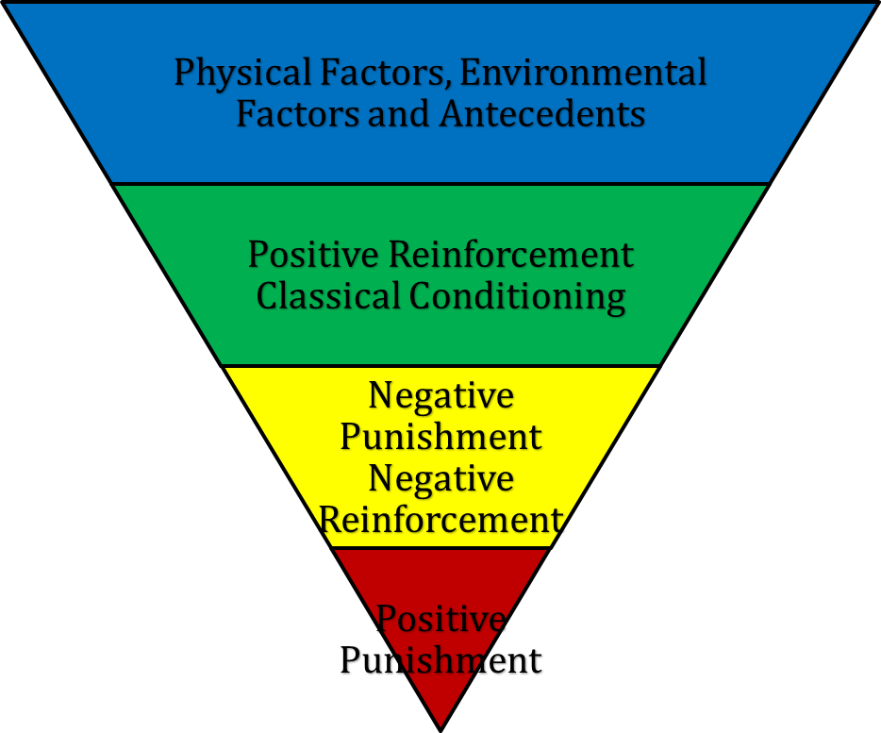

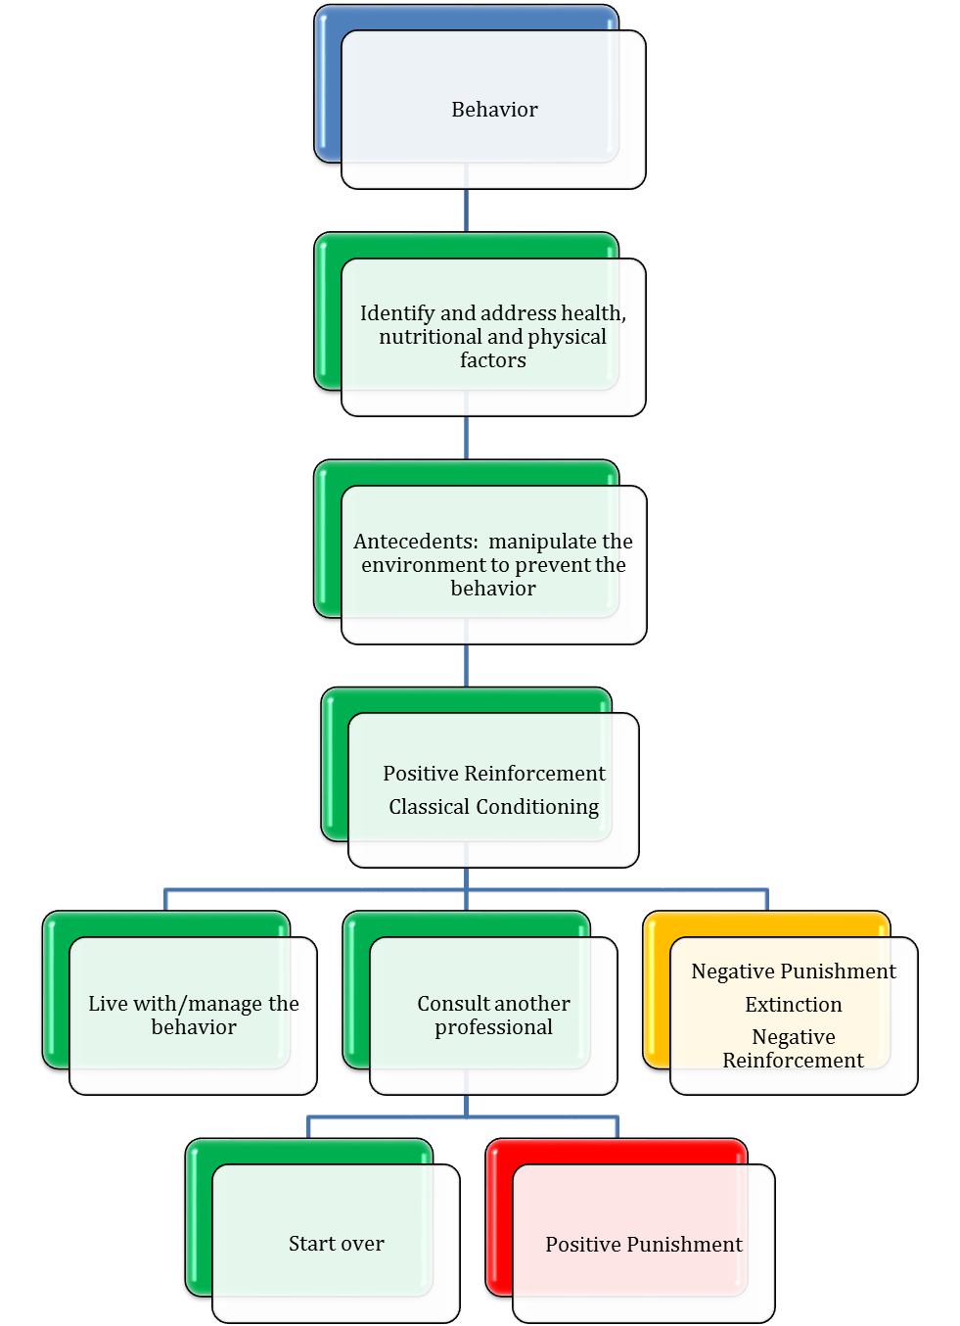

Please direct any questions regarding this standard of care to our administrator at board@ccpdt.org .

.

